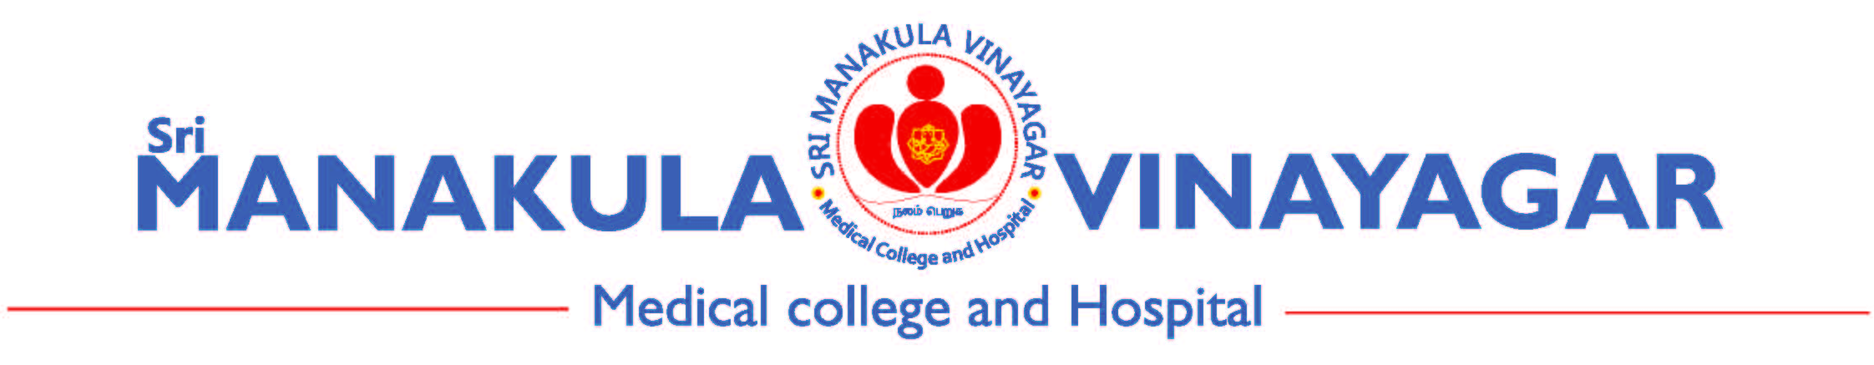

Annexure 01/SOP/11/V2.1
Protocol Violation / Deviation Reporting Form (Reporting by case)

SMVMCH-EC Ref. No. (for office use) :

Title of study:

Principal Investigator (Name, Designation and Affiliation):

- Date of EC Approval: Date of Start of study:
- Participant ID: Date of occurrence:
- Total number of deviations /violations reported till date in the study:

- Deviation/Violation identified by: Principal Investigator/study team Sponsor/Monitor
SAE Sub Committee/EC
- Is the deviation related to (Tick the appropriate box) :
Consenting Source documentation
Enrollment Staff
Laboratory assessment Participant non-compliance
Investigational product Others (specify)
Safety reporting

- Provide details of Deviation/Violation:

- Corrective action taken by PI/Co-PI:

- Impact on (if any): Study participant Quality of data
- Are any changes to the study/protocol required? Yes No

If yes, give details

Signature of PI with date

